Continuing Education Courses at Now I See A Person Institute (NISAPI)
CAMFT APPROVED PROVIDER 135076
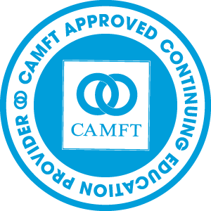
Now I See A Person Institute (NISAPI) is offering coursework in Collaborative Practices including Community Engagement: A Collaborative Recovery Model (CEACRM). CEACRM combines Collaborative Language System Approach (CLS) with Recovery Theoretical Practices. Dr. Susan Swim was instrumental both in the development of CLS and CEARCM. CEACRM is an evidence based model used for clients not successful in traditional therapy or psychiatric services. All faculty of NISAPI have completed certificate programs.
Our programs run year round and we will be offering Law and Ethics Workshops and an Introduction and Refresher Course to CEACRM-CLS that’s starts in April 2017 and continues every month.
NISAPI offers an International Certificate Program in Collaborative Practices. NISAPI offers a certificate program in CEACRM. All workshops will offer Continuing Education approved by CAMFT. One can enroll in one class or take a series for a certificate completion. Please email for more information.
Friday, June 23, 2017 Introduction to RECOVERY THOERIES: CEACRM & CLS: 4 hours CEU 12:30PM-5PM and for beginners to CEACRM-CLS or a refresher course $ 150.00* $130.00
Saturday, June 24, 2017 Law and Ethics Part I: 3 hours CEU 1PM-5PM $150.00* $130.00
Sunday, June 25, 2017 Law and Ethics Part II: 3 hours CEU 1PM-5PM $150.00* $130.00
Saturday, June, 29 2017 Helping families who have a family member with chronic illness: 3 hours CEU 12:30 PM-4PM $150.00* $130
For more information visit www.nowiseeaperson.com or email admin@nowiseeaperson.com or swimincinc@aol.com call Dr. Swim at 626-487-9305/David 310-993-9144
*Discounted Spring Series

