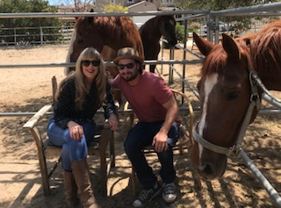  Summer Therapeutic Camp at Now I See A Person Institute  Our theory and philosophy of services called, Community Engagement A Collaborative Recovery Model (CEACRM) is evidence based through seven years of qualitative research. Our research reflects up to 98% recovery from symptoms (representative of clients who actively participate in services until termination). CEACRM reflects collaboration, highlighting inherent client strengths and where clients and families are able to obtain sustainable change. All services happen at a horse ranch within venues that promote natural, normal and nurturing environments. In our research clients’ report “feeling like they weren’t having therapy” was paramount in their journey to change.  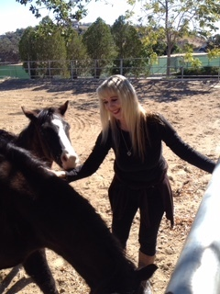 | - Clients will be assigned to a treatment team.  - Clients will attend individual, group and family therapy.  - Clients will help define their individual and team goals.  - Clients will interact with ranch life. This will not involve riding horses. Our research reflects using the horses as co-therapists is enhanced when not on a horse.  - Cost Per Client: $72.50 per hour for two hours a week, five days a week for eight weeks.  Summer Therapeutic Summer Camp at Now I See A Person Institute  Contact: Dr. Susan Swim 626-487-9305 or David Abramovitch 310-993-9144  Scholarships available  Inquire about our additional multiple group sessions for trauma, couple counseling, childhood behavioral challenges and much more…  NISAPI a 501 C3  ────  ────  ────  ────  Company Name  Street Address  City, ST ZIP Code  Telephone  Web Address  Dates and Times

