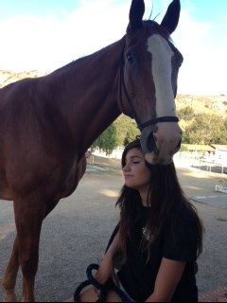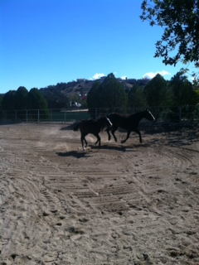

To join our communities contact Dr. Susan Swim at [swiminc@aol.com](mailto:swiminc@aol.com). We wish to self-tailor your time with us. Come for a day, week, month or year long.

We are one learning community embracing another…

9633 Baden Ave.

Chatsworth, CA 91311

Phone: 626.487.9305

[www.nowiseeaperson.com](http://www.nowiseeaperson.com)

swiminc@aol.com

**Join Us at**

***Now I See A Person Institute***

# Relational Hosting at NISAPI

Open to all Taos Associates, we offer you to come and actively witness our recovery model in a naturalistic environment where horses are often the co-therapist.

We hope you will bring your passion and enthusiasm while you become a part of our team in NISAP’s community & recovery based approach. Diagnoses or labels become obscure and people are seen as people. Witness self-created change in a climate of normalcy at a horse ranch where freedom abounds.

Please visit [www.nowiseeaperson.com](http://www.nowiseeaperson.com) for a “closer” look at our work.

# Become Immersed in our Community

Come join our team of therapists at Now I See A Person Institute and experience our therapy combining horses and treatment which fosters hope, new possibilities, transformation and new identities.

# An Alternate Approach…

**To those diagnosed with severe mental health and substance themes as well as those suffering from violent crime and trauma. Our referrals are from the department of mental health, children’s protective services and victims of crime.**

**Relational Hosting at**

***Now I See A Person Institute***

#### Rebuilding Lives with Equine Healing. Here we See you as A Person…

**Not as a diagnosis that may have defined or limited you in the past…Here WE believe in YOU**

# Now I See A Person Institute: Promoting hope and collaborating for change

Specializing in Community Engagement: A Collaborative Recovery Model.

NISAPI is a 501c3 incorporating the use of horses and Community Engagement: A Collaborative Recovery Model.